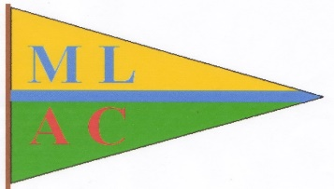  Happy and safe boating | Myall Lakes Aquatic Club
“Respect the Past – Create the Future” NOVEMBER 2021

2021 AGM AND XMAS
Bombah Point was selected as our venue this year to hold our Covid deferred AGM meeting and a low-key Xmas get together. While the venue proved to be most successful for the meeting and meal, but for a boating venue, the weather was far from kind. The Friday started out pleasantly with boats arriving and berthing at the pump-out pontoon into the early evening. Carroa, Independence, Kiandra, Toy Ship, Harmony and Ampolla managed a very pleasant Happy Hour which started at the Resort and finished at the pontoon just as a furious and determined wind howled in from the west and then blew determinedly for the rest of the weekend. Shallamar arrived as the wind was freshening and probably wisely took up a swing mooring.
With the wind still ferocious and broadside in the morning, our most competent and decisive Commodore with his able assistants re-arranged the flotilla and further secured mooring lines to make room for another arrival. River Gypsy, dripping wet from her exhilarating crossing of the Broadwater on her maiden voyage, following an extensive renovation, was ushered safely into a secure berth.
Incredibly, the wind managed to even strengthen more throughout Saturday and eventually gale force and the Car Ferry was forced to shut-down. Later in the afternoon, other boat club members started arriving, comfortably snug and secure in their vehicles and looking down on the windswept bouncing fleet, thanking their Gods for deciding not to come by boat.
An impressive group of 33 members gathered at the restaurant for a Club catered meal and the AGM. One enthusiastic member drove all the way from Singleton and returned home again before the meal, just to be present for the AGM. He was not disappointed and commented,” it was one of the most professionally and competently run small club meetings he has attended.”
The AGM was underway and following the standard practices, the Commodore’s and the Treasurer’s reports were presented to the membership, then the current committee stood down and Mal Muddle as the returning officer, smoothly announced the nominations for the new committee and declared the following persons elected.
Myall Lakes Aquatic Club Website: www.mlac.org.au Commodore: Rod Blanch commodore@mlac.org.au
ABN: 88 396 838 568 Secretary: secretary@mlac.org.au

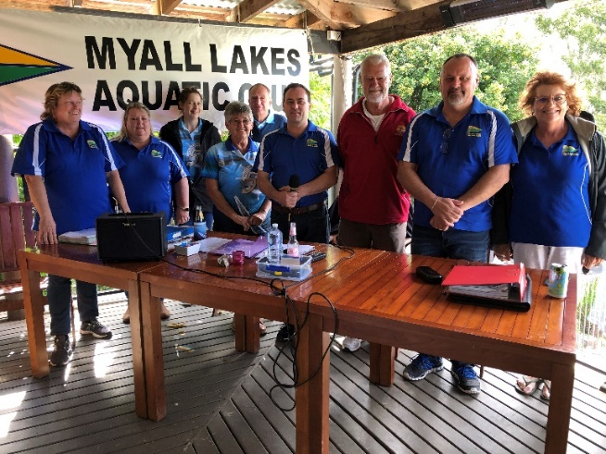
The committee is Commodore Rod Blanch, Vice Commodore Allan Tennyson, Rear Commodore Rebecca Muddle, Treasurer Paul Bendy, Secretary Linda McIntosh, Committee persons Melissa Blanch, Mac McIntosh, Narelle Tennyson and welcome to committee Christine Preston. Retiring from the committee is Wendy Hammond and we thank and will miss her for the contribution she quietly achieved behind the scenes.
Formalities over, members enjoyed catching up over dinner and capped the night off with a fun Xmas trivia organized by Wendy.
A big thank you to present and all past committee persons for your dedication, time and effort in keeping this great club running for 51years.
As Commodore Rod stated in his report, this club is more than just a social group but also performs other valuable roles, like boating education, maintenance of boating facilities around the Myalls, not just for the present, but ensuring their future. Not so obvious, but very significant is ensuring good professional relations with the various authorities with which we have interaction and interdependence to keep floating and boating.
The Committee wish all our members and their families a safe and happy Christmas and we look forward to once again enjoying club activities on our wonderful waterways in 2022.

